**MEDIGUIDE**

*A*

*Mini Project Report*

*Submitted in partial fulfilment of the*

*Requirements for the award of the degree of*

**BACHELOR OF ENGINEERING**

IN

**INFORMATION TECHNOLOGY**

By

**Kalthi Reddy Gayathri (1602-19-737-013)**

**Jampelly Sai Rishitha (1602-19-737-036)**

**Aare Sai Deepika (1602-19-737-305)**

*Under the guidance of*

**B. Leelavathy**

**Assistant Professor**



**Department of Information Technology**

**Vasavi College of Engineering (Autonomous)**

**(Affiliated to Osmania University) Ibrahimbagh**

**Hyderabad-31**

**2021-2022**

**Vasavi College of Engineering(Autonomous)**

**(Affiliated to Osmania University) Ibrahimbagh**

**Hyderabad-500031**

**Department of Information Technology**



**DECLARATION BY THE CANDIDATES**

We, **Kalthi Reddy Gayathri, Jampelly Sai Rishitha, Aare Sai Deepika**, bearing hall ticket numbers **1602-19-737-013, 1602-19-737-036, 1602-19-737-305**, hereby declare that the project report entitled “MEDIGUIDE” under the guidance of **Ms. B. Leelavathy**, Department of Information Technology, Vasavi College of Engineering, Hyderabad, is submitted in fulfilment of the requirement for the award of the degree of **Bachelor of Engineering** in **Information Technology**.

This is a record of bonafide work carried out by us and the results embodied in this project report have not been submitted to any other university or institute for the award of any other degree or diploma.

**Kalthi Reddy Gayathri (1602-19-737-013)**

**Jampelly Sai Rishitha (1602-19-737-036)**

**Aare Sai Deepika (1602-19-737-305)**

**Vasavi College of Engineering(Autonomous)**

**(Affiliated to Osmania University) Ibrahimbagh**

**Hyderabad-500031**

**Department of Information Technology**



**BONAFIDE CERTIFICATE**

This is to certify that the project entitled “**MEDIGUIDE**” was submitted by **Kalthi Reddy Gayathri, Jampelly Sai Rishitha, Aare Sai Deepika** bearing **1602-19-737-013, 1602-19-737-036, 1602-19-737-305** in fulfilment of the requirements for the completion of **MINI PROJECT** of Bachelor of Engineering in Information Technology is a record of bonafide work carried out by them under my guidance.

**Ms. B. Leelavathy Dr. K. Ram Mohan Rao**

**Internal Guide HOD, IT**

**ACKNOWLEDGEMENT**

It is our privilege and pleasure to express a profound sense of respect and gratitude to our guide **Ms.** **B.Leelavathy**, Assistant Professor, Department of Information Technology, Vasavi College of Engineering, for her indefatigable inspiration, guidance, cogent discussion and encouragement throughout this dissertation work.

I am grateful to my project guide **Mr. K. Srinivasa Chakravarthy**, Assistant Professor, Department of Information Technology, Vasavi College of Engineering, for guiding us throughout the project.

We express our sincere gratitude to **Dr.** **K. Ram Mohan Rao**, Professor & Head, Department of Information Technology, Vasavi College of Engineering, for his suggestions, motivations and co-operation for the successful completion of the work.

We extend our sincere thanks to **Dr. S. V.Ramana,** Principal, Vasavi College of Engineering for his encouragement.

Our sincere regards to the entire faculty and staff of the Department of Information Technology, Vasavi College of Engineering, for their cooperation and help.

**TABLE OF CONTENTS**

ABSTRACT ………………………………………………………………………….............. 6

INTRODUCTION …………………………………………………………………………..... 7

* 1. Overview ……………………………………………………………………………. 7
  2. Objective ……………………………………………………………………………. 7

LITERATURE SURVEY ………………………………………………………………………. 8

EXISTING SYSTEM …………………………………………………………………………… 9

4.1 Drawbacks …………………………………………………………………………. 9

SYSTEM REQUIREMENTS and SPECIFICATIONS …………………………….. 10

PROPOSED METHOD ……………………………………………………………………. 11

6.1 Architecture ……………………………………………………………………. 11

IMPLEMENTATION ………………………………………………………………………. 12

RESULTS ………………………………………………………………………………………. 14

CONCLUSION and FUTURE SCOPE ………………………………………………… 19

9.1 Conclusion ………………………………………………………………………….. 19

9.2 Future Scope ………………………………………………………………………. 19

References …………………………………………………………………………………… 20

**ABSTARCT**

In our everyday life we go over numerous individuals who are experiencing some sort of Diseases. Prediction of disease is an integral part of treatment. In today's period, every person relies on allopathic treatments and medicines. This application provides an interface to recommend drugs to users suffering from a particular disease which would also be diagnosed by the framework through analysing the user's symptoms by the means of machine learning algorithms. The patient can without much of a stretch recognize the diseases. The patients can undoubtedly recognize the disease by simply ascribing their issues and the application interface produces what malady the user might be tainted with. Predictive analysis would be performed on the disease that would result in recommending drugs to the user by taking into account various features in the database. Some people may even want to consult hospitals to get further information of treatments available for their disease. For such people this application will provide with the hospitals nearby them.

**INTRODUCTION**

* 1. **Overview**

Basically search based applications filters all the contents and outputs the results that matches the search content of the user. These applications are used to retrieve the desired content faster using a keyword. This web application is designed to output desired content based on the search keyword of the user. These days many prefer to use maps to locate a particular place. So, this web application also locates the desired hospital on the maps. Prevention is better than cure. Many prefer to get tested at home rather than going to a hospital, to such people this application helps in predicting disease and recommending a medicine.

* 1. **Objective**

Mediguide is a web application that is used to retrieve hospitals list using either the state name, city name or the pincode of the area, predicts the disease through the symptoms entered by the user and recommends medicine. Also, user can know what are all the government schemes and the information related to them like eligibility criteria etc present in a particular state by just giving the state name .

**LITERATURE SURVEY**

Author Ahmed M. Alaa and Senthil Kumar Mohan have experimented with a combination of different factors and obtained 88.7% accuracy with a random hybrid forest. Aim of this project was to improve treatment using ML technology to simplify the decision support system. Another work deals with classic supervised binary classification where it is given a number of attributes in the dataset. The dataset includes Plasma glucose concentration Blood pressure, Body mass index Age etc.

**EXISTING METHOD**

**4.1 Drawbacks**

In the present systems, if a patient after getting recommended a medicine wants to search for hospitals for treatment purposes, the system does not provide the patient with hospitals details. This is problem is solved in our web application. The present systems are not easily accessible everywhere in most of the area, only the tradition health care system exists.

**SYSTEM REQUIREMENTS and SPECIFICATIONS**

**Software Requirements :**

* Streamlit
* Python :
* Numpy
* Scipy
* Matplotlib
* Pickle
* Random

**Hardware Requirements :**

* Operating system : windows/linux
* RAM : 2GB
* Hard drive : 16Gb

**PROPOSED METHOD**

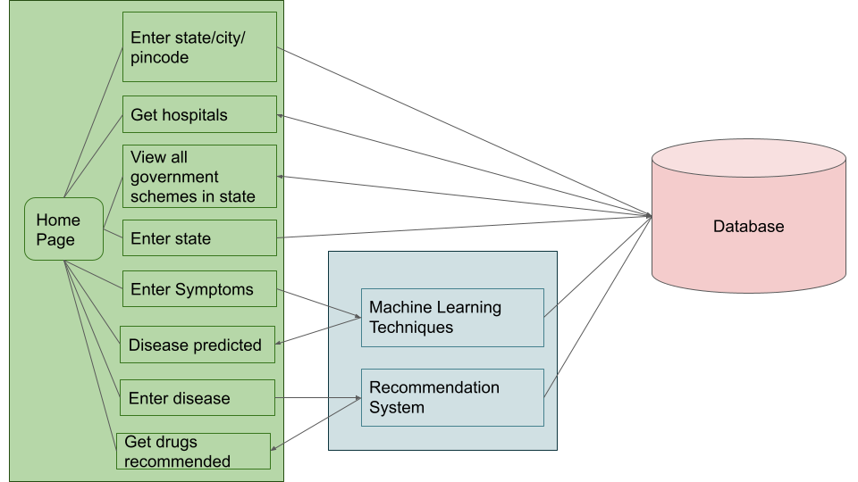**Architecture :**

**Disease Prediction Flow :**

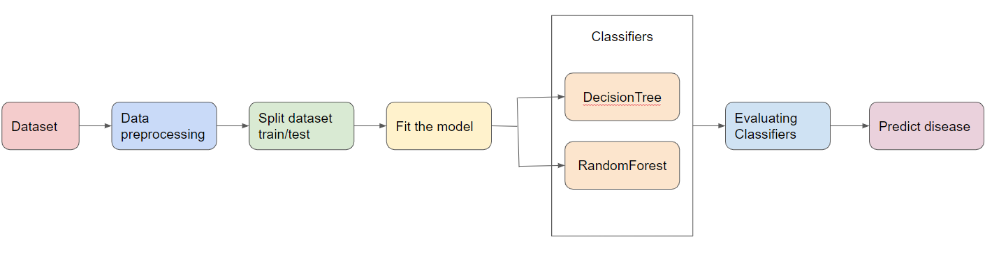

**IMPLEMENTATION**

1. Home

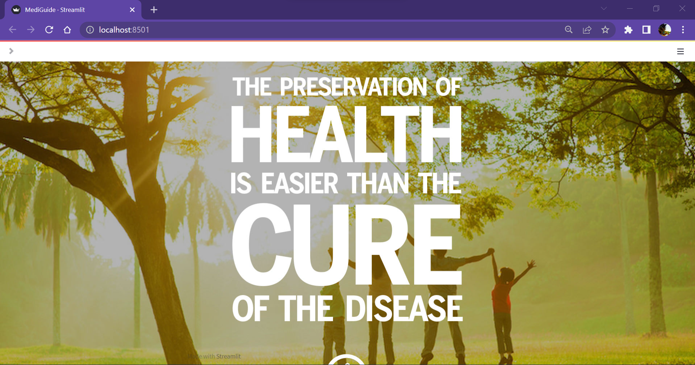

1. About

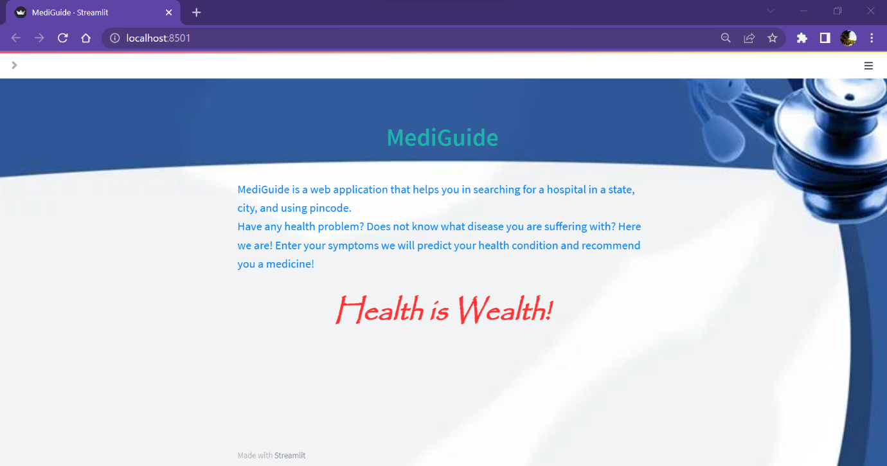

3. Contact

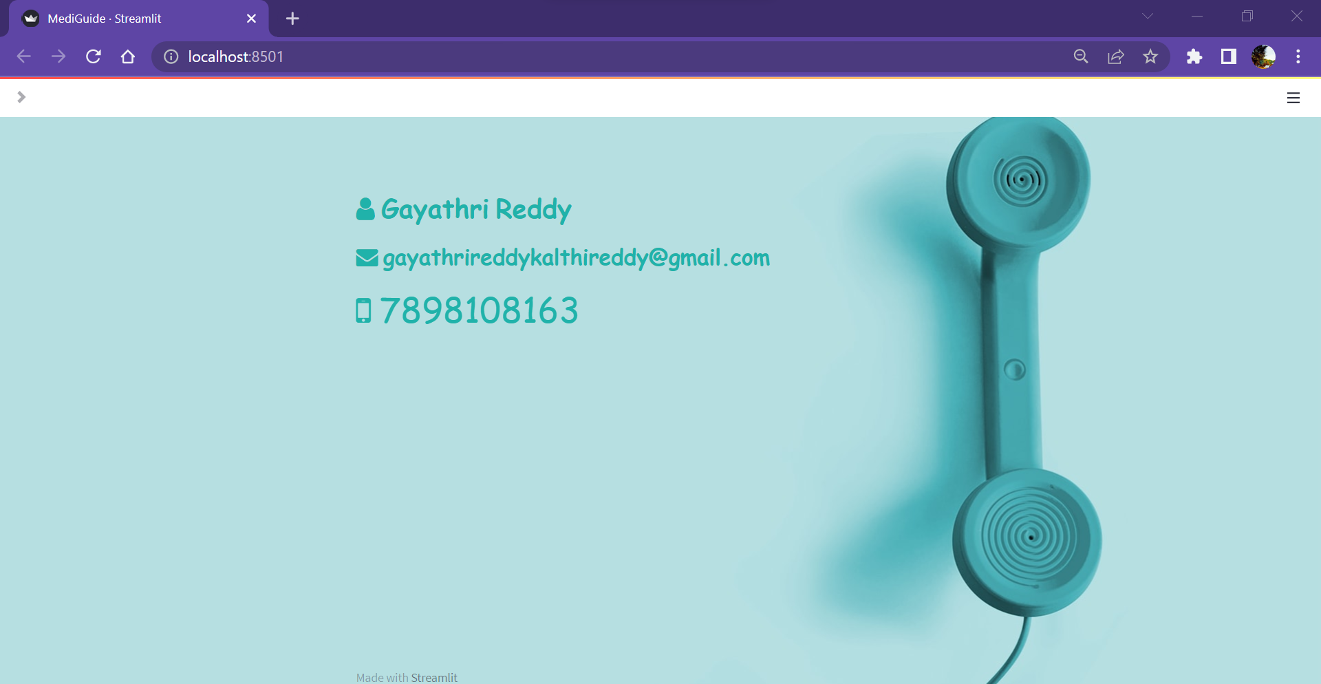

**RESULTS**

1. Hospitals in a particular state

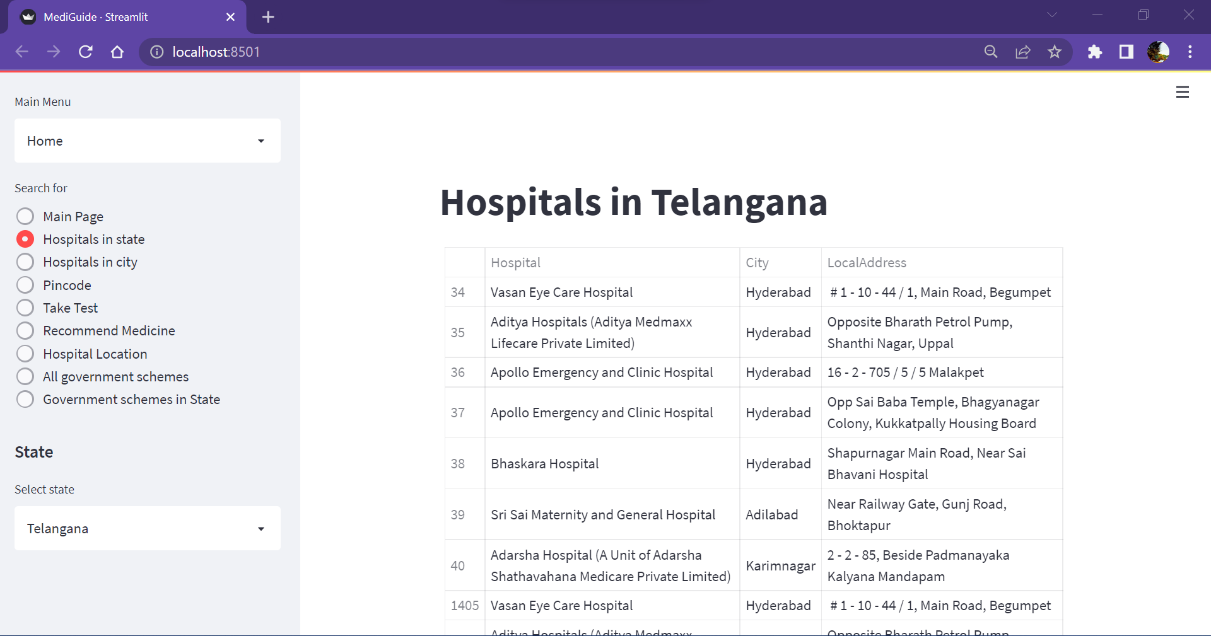

1. Hospitals in a particular city

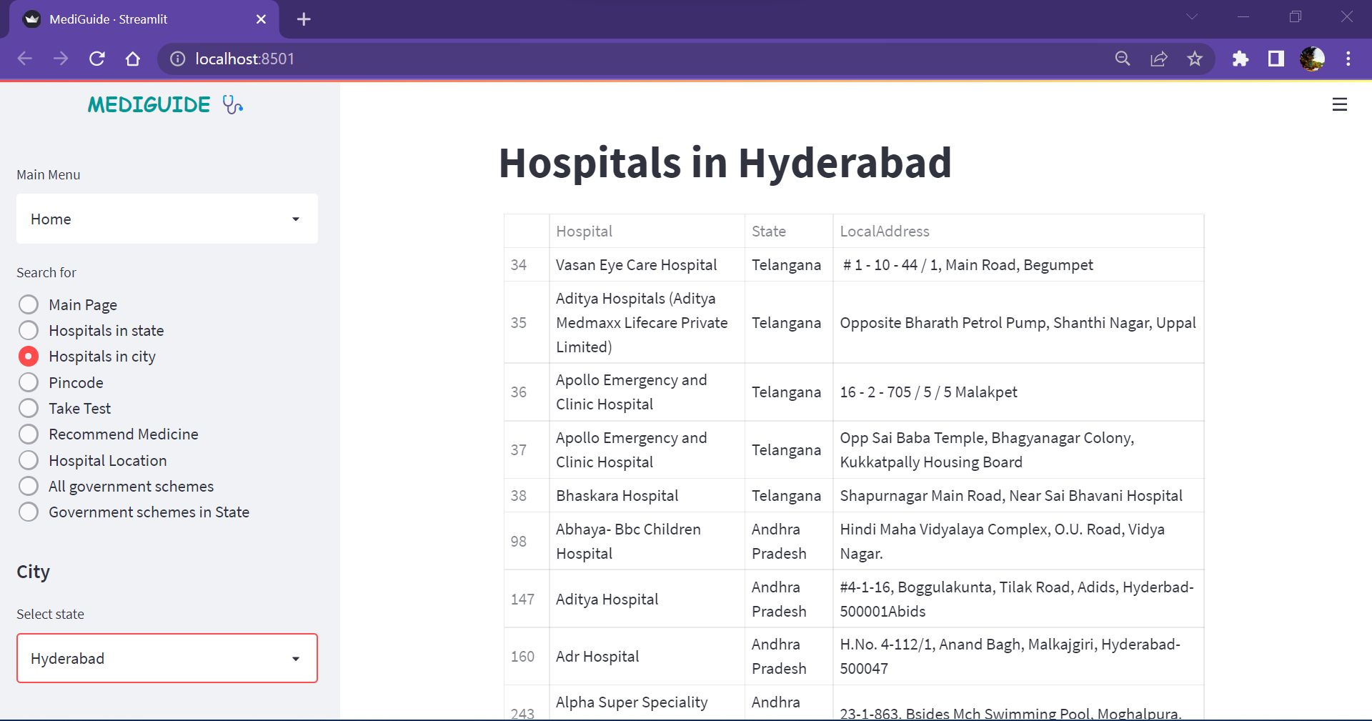

1. Hospitals in area with a given pincode

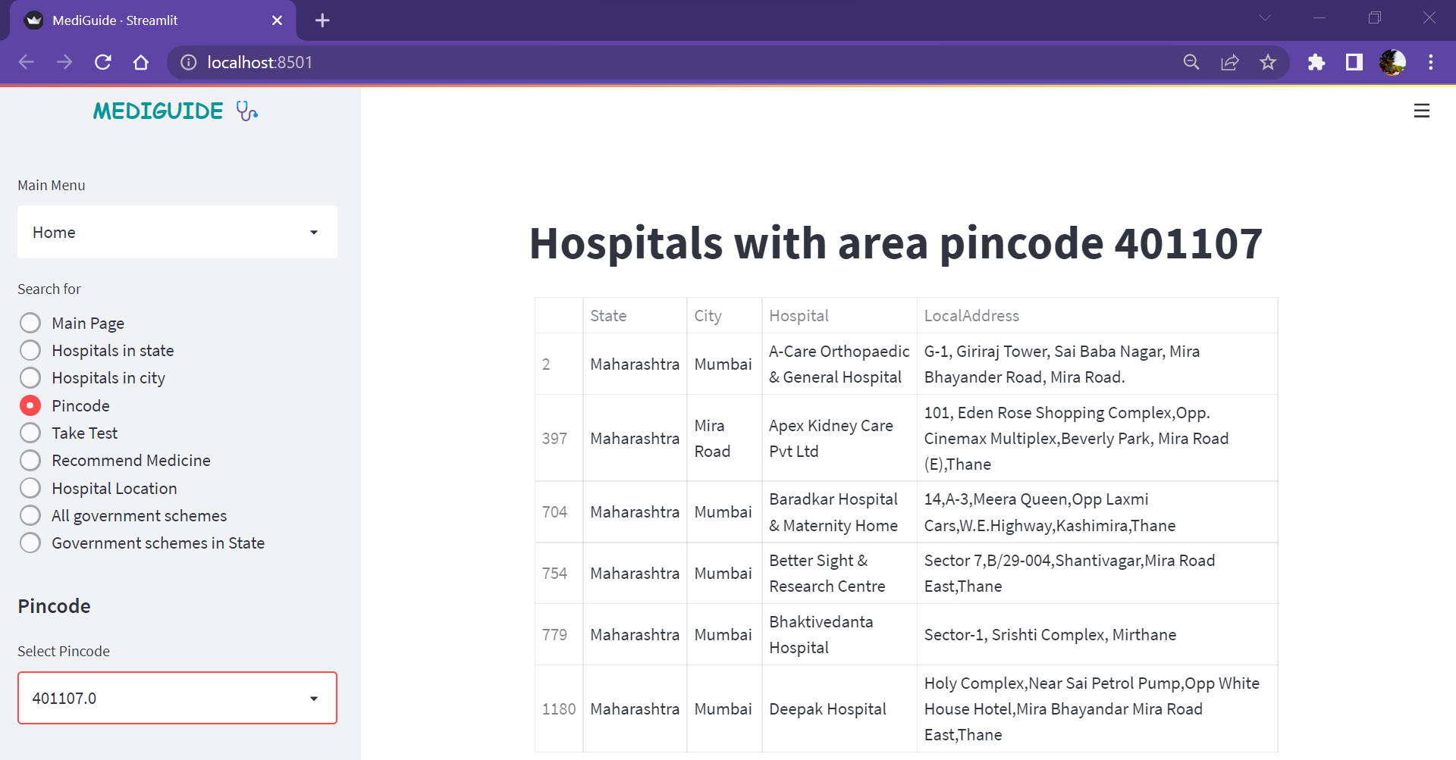

1. Disease prediction using symptoms

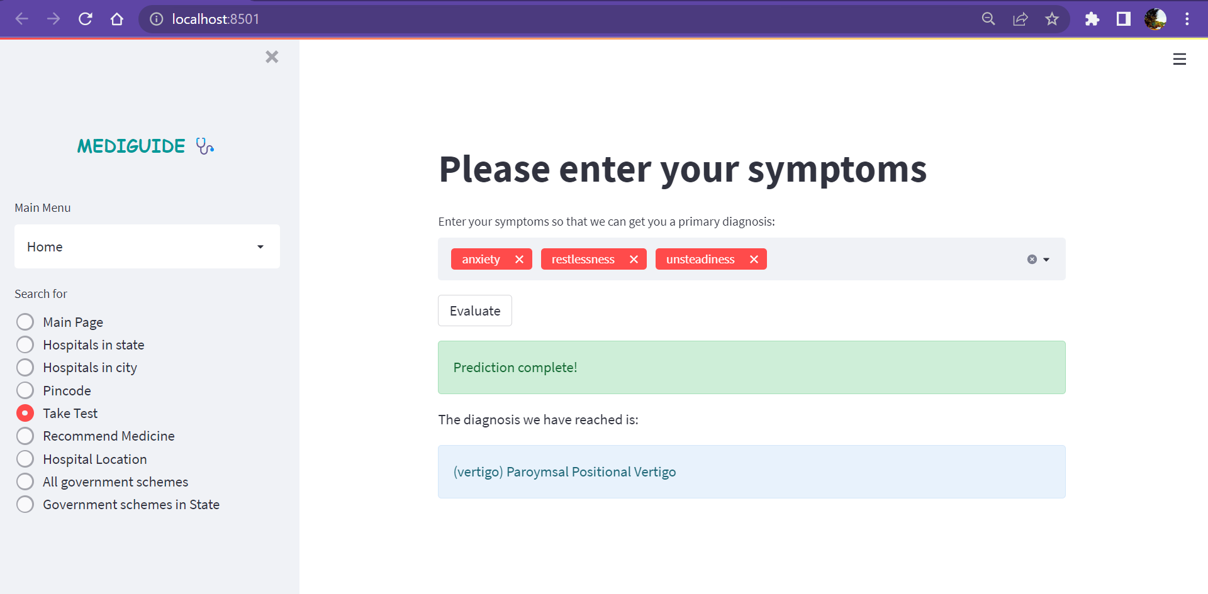

1. Drug recommendation

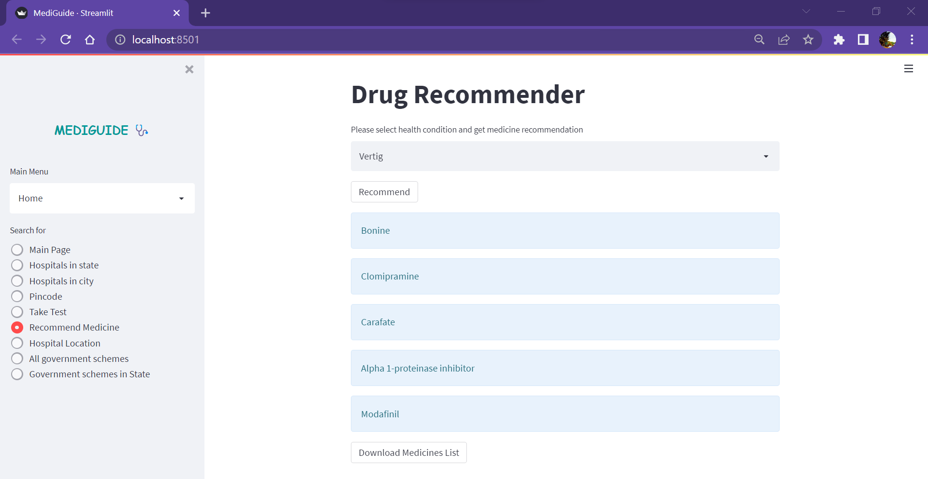

1. Download prescription

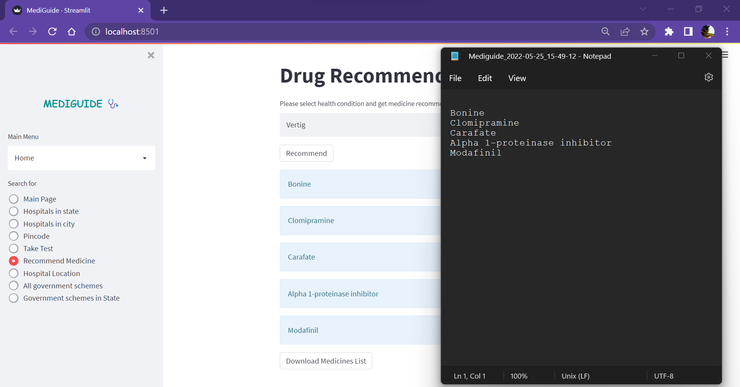

1. Locate hospital on map

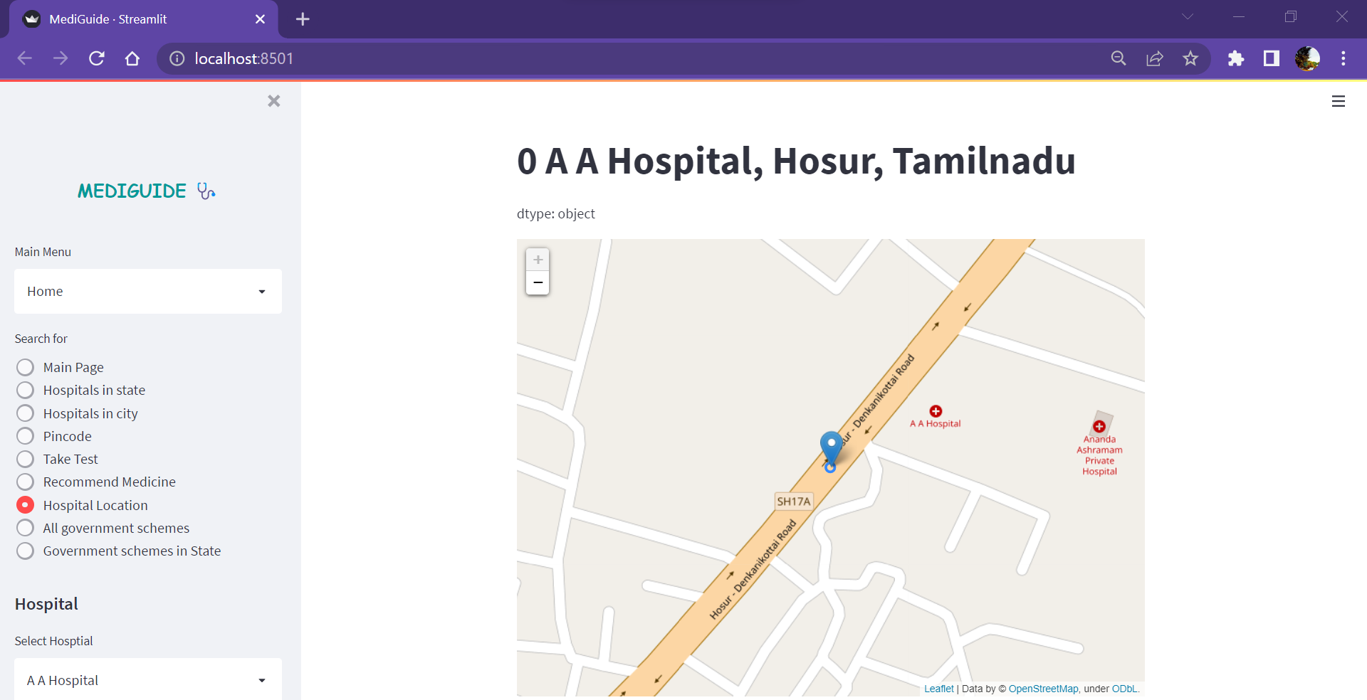

1. All government schemes in India

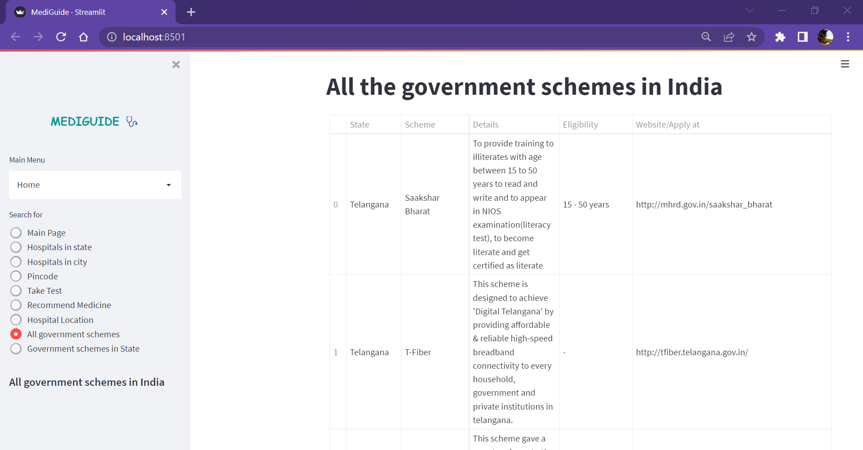

1. Government schemes in a particular state

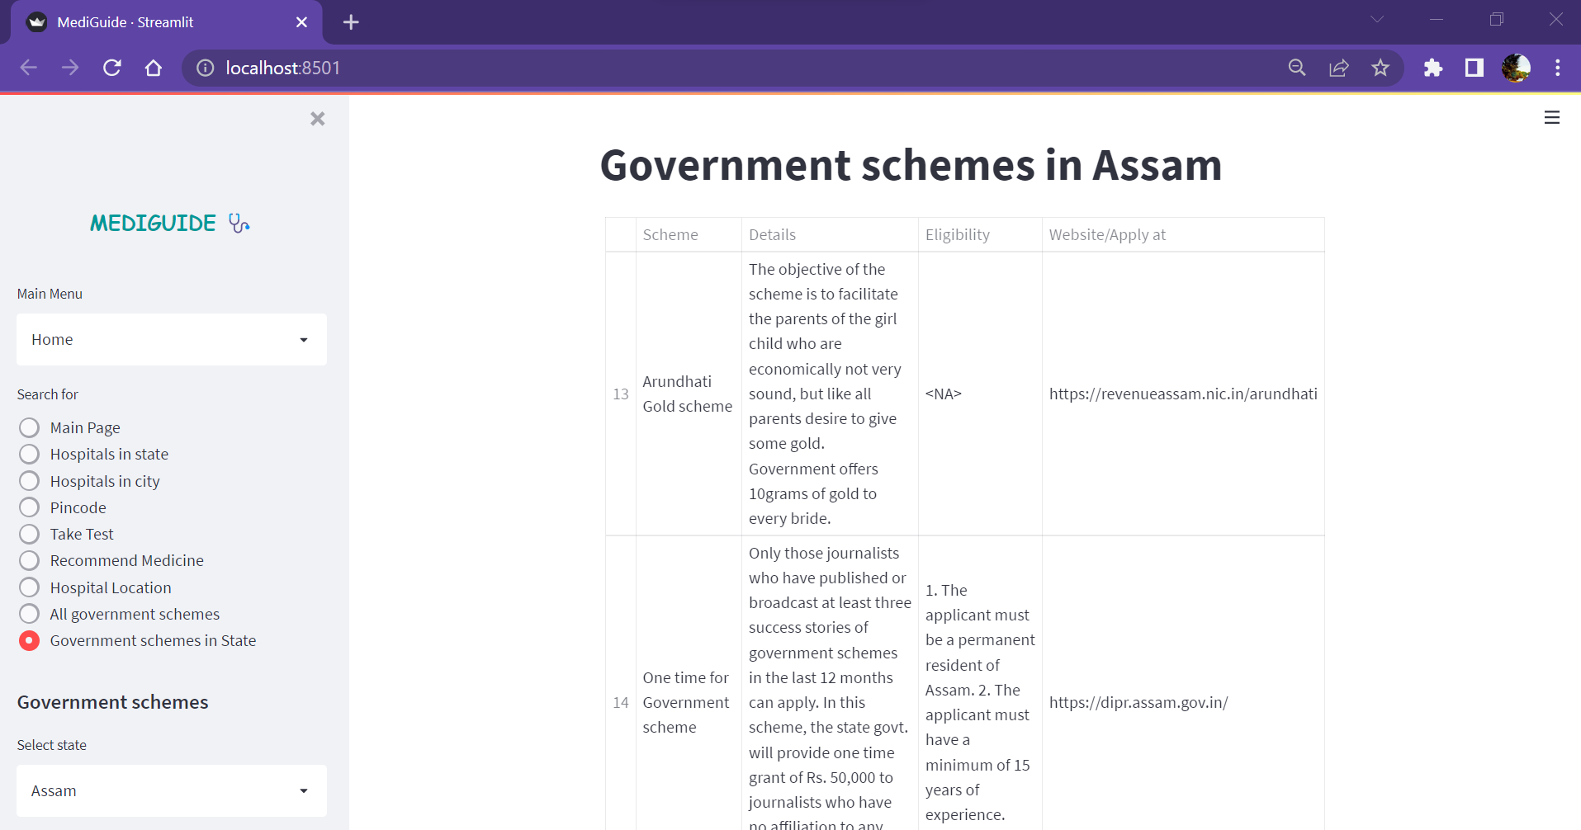

**CONCLUSION and FUTURE SCOPE**

* 1. **Conclusion**

The web application completely meets the objectives and requirements of the system. The application could successfully output the hospitals based on the input (state name, city name or area pincode) given and it could successfully output the government schemes based on the input given by the user.

* 1. **Future Scope**
* To add features like quizzes to know the user more and output government schemes
* To recommend best hospitals and doctors for a disease in the patients location
* To suggest affordable hospitals

**REFERNCES**

* Streamlit official documentation: <https://docs.streamlit.io/en/stable/>
* <https://towardsdatascience.com/create-a-simple-search-engine-using-python-412587619ff5>
* Decision tree and random forest exploration:

<https://www.khanacademy.org/computing/computerscience/informationtheory/info-theory/pi/decision-tree-exploration>